Multi-Connectivity in Edge Computing Using RNN Algorithm & MQTT Protocol
신진영
성균관대학교 소프트웨어대학
wlsdk0710@naver.com
Shin Jin Young
Sung Kyun Kwan University, College of Software
요 약
As number of devices which need network increase. Necessity of new technology for managing massive connectivity came to light. This research adopts Recurrent Neural Network(RNN) algorithm to manage multi connectivity. Research develops the most ideal algorithm by strict analysis. And the developed method is going to be applied on network managing hub combined with LPWAN(Low-Power Wide Area Network) based connectivity managing technology. Selection and application of best fit method by dealing with kinds of RNN algorithm, we expect gaining outstanding performance on network management. And the performance would lead popularization of edge computing.

1. 서 론

It is unable to overemphasize importance of IoT technology these days. Frequently used word ‘Connected World’ explains well about era of IoT. Recent predictions say that there will be around 30 ~ 50 billion IoT nodes at 2020. On growth of IoT, researches to deal with large scale future network are prevalent. For example, breaking down the nodes into smaller pieces. Let’s suppose a switch(power) of the entire room’s light was a connected node, movement spreading the nodes to whole light(lamps) is on.

Wireless technology has been facing necessity of change as Connected World coming to reality. Current connectivity managing algorithm is MADM(Multiple Attribute Decision Making). MADM algorithm can be devided into algorithm like SAW(Simple Additive Weighting), MEW(Multiplicative Exponential Weighting), TOPSIS(Technique for Order Proference by Similarity to an Ideal Solution), VIKOR. But, MADM algorithm seems not to fit right in massive connected IoT environment. The reason is MADM sets priorities by weighting on specific elements. And core factor is that it is unable to get dynamic location of nodes with MADM. In other words, MADM cannot consider variety of factors which should be handled in IoT network environment. That is why another algorithm for IoT usage become necessary. This paper contains proposal of IoT environment fit algorithm(RNN) and application of RNN to multi-connectivity.

'Edge Computing' was a big issue in IT fields of 2016. The concept of edge computing is locating data center near users so that faster speed service could be offered. Before edge computing central data center covered whole users. Now edge data centers cover separate area. This new concept of service could lower latency of service time and users could experience more real-time like service with high quality.

RNN(Recurrent Neural Networks) is a kind of artificial neural network. By using RNN, we will be able to realize memorizing function similar to human brain.

These lists above are typical example of RNN. Though there are a lot to deal with, we will focus on Long Short-Term Memory Network(LSTM) in this paper. LSTM is the most frequent used method among other methods. Major problem on usage of RNN is that as process goes deep, it is hard for the network to have old data. With emergence of this kind of matter, LSTM, which could be considered evolved version of RNN appeared. Unlike other RNN methods, LSTM networks are not affected by time.

Principle of LSTM is classifying of memory to two class. One can be held for long duration of time and the other does not. Which means LSTM does not have data vanishing phenomenon.

One of the most remarkable feature of RNN is handling with dynamic data. This feature allow RNN to be used in the fields dealing with changable and unsegemented kind of data.

This research cover applying RNN to multi-connectivity. Proper application of the algorithm would bring effective scheduling of network on dealing with massive connectivity. RNN on multi-connectivity can be a solution for absence of optimized IoT management algorithm. Applied technology can be efficiently used at hub which schedules IoT network.

This research would cause improve performance of LPWAN especially in sorting and scheduling of requests. The enhanced performance in network managing technology would contribute to maintain stable network in edge computing.

Edge computing is now inevitable technology for enterprise or service agent to offer more rapid, available, scalable service. This research would help establishing fine connectivity management in Edge computing world.

2. 본문
2.1 관련연구
To handle growing number of nodes in upcoming ‘Connected World’, this paper suggest applying RNN algorithm to connected nodes with edge server.

By applying RNN algorithm on multi-connectivity, we can expect to gain more performance on connection speed. With the gained performance, it could be adopted on edge computing node. Nodes are about to be more split when we are on edge computing, so characteristic of RNN would help building smooth communicating networks.

We can get Sn by adding 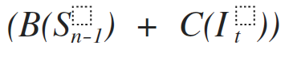.
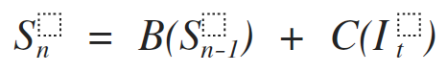

In connecting nodes in edge computing, we can apply this RNN algorithm. Connectivity with this algorithm would be associated with edge computing server.

2.2 결과
With RNN algorithm applied in connectivity. Each Nodes and connecting path may be memorized if nodes are connected at least once. Combined with edge computing server near user, we could expect faster and safe connection.

MQTT Protocol is considered to be an ideal one among IoT communication protocols. Because it can manage connection of number of nodes(~10K) and it is designed for light-weight data communication.

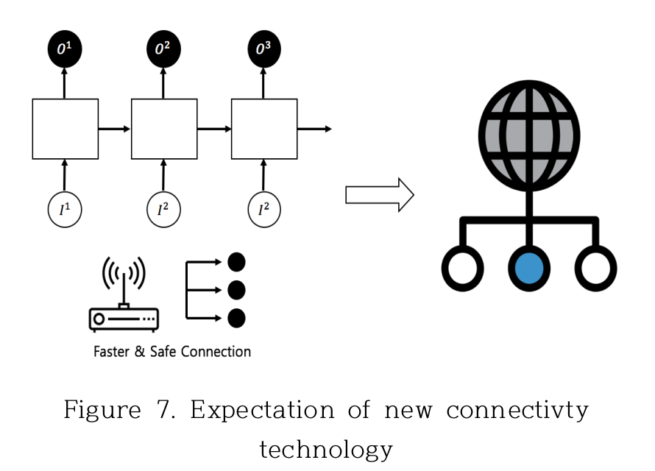

To deal with exponentially growing number of nodes, this connecting method apllying RNN on connection and MQTT on communication introduced in this paper could be one of a solution. We can expect fast connection and stable and efficient service and our world would meet more convenient IoT world.

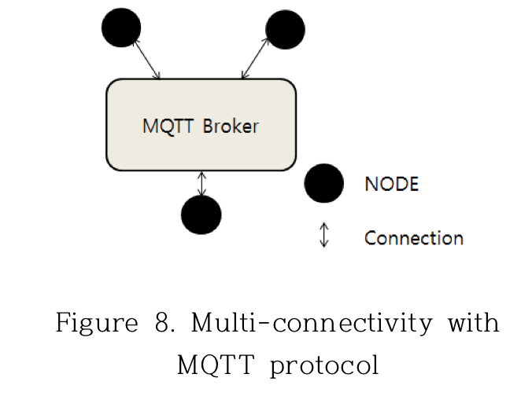

3. 참고문헌
[1] Optimal Network Selection Using MADM Algorithms, Manisha, N.P. Singh, NIT Kurukshetra, India, 2015

[2] CNN And RNN Algorithm Analysis Based on Deep Learning, Na-Rae Jo, Seok-Cheon Park, Jong-Hyun Kim, Duck-Yeul Hwang, Korean Society For Internet Information, 2016.11

[3] Deep Recurrent Neural Network, Kyungjoong jeong, Jaesik Choi, Korea Information Science Society, 2015.8

[4] Recurrent Neural Network Tutorial, Team AI Korea

[5] Chapungu, George. "Limitations of Mobile Computing." Web log post.Wells Digest. N.p., 1 Aug. 2013. Web. 30 Nov. 2014.

[6] Livingston, David. "Introduction & History of Mobile Computing."Slideshare. Linkedin Corporation, 5 Dec. 2013. Web. 30 Nov. 2014.

[7] Personalized Service Recommendation for Mobile
Edge Computing Environment, JongChul Lim, SangHa Kim, Chang Sup Kim , 한국통신학회논문지 제42권 제5호, 2017.5

[8] On-site construction management using mobile computing technology, Changyoon Kim, Taeil Park , Hyunsu Lim , Hyoungkwan Kim, Korea Institute of Construction Technology

[9] Connectivity and networks for the Internet of Things data deluge, i-scoop

[10] A guide to IoT analytics, Andrea Reale, February 2017. 9. 15.

[11] Recurrent neural networks tutorial, Part1 – Introduction to RNNs, Denny Britz, Sep 2017

[12] Recurrent neural networks tutorial, Part2 – Implementing a RNN with Python, Denny Britz, Sep 2017

[13] CNN과 RNN의 기초 및 응용 연구, 이은주, The Korean Society Of Broad Engineers, 2017

[14] A Survey on Requirements of Application in Mobile Edge Computing, Jin-Seop Lee, Seong-Soo Cho, Tae Hwan Jung, Eui-Nam Huh, 2016년 동계학술발표회

[15] Personalized Service Recommendation for Mobile Edge Computing Environment, Jong-choul Yim , Sang-ha Kim , Chang-sup Keum, The Journal of Korean Institute of Communications and Information Sciences, May 2017

